Lab Series No. 13.

*Lab 13 –Introduction with Tkinter.*

* + - 1. Write a program which will make a simple calculator.

**CODE:**

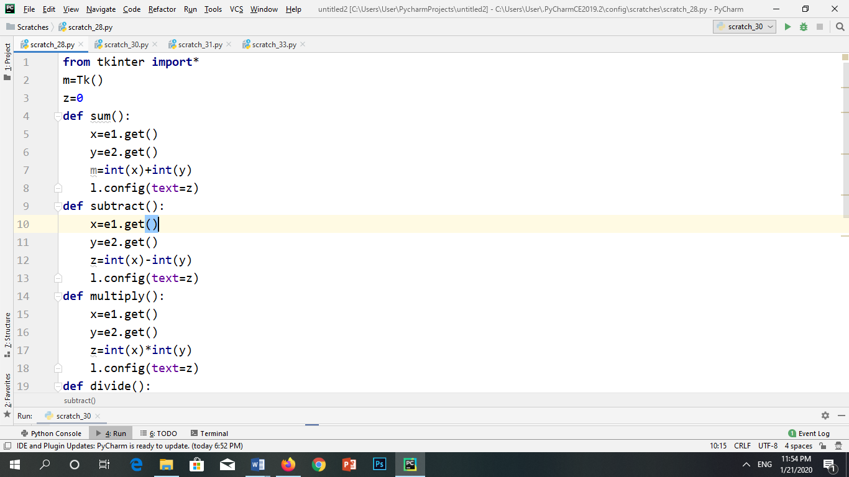

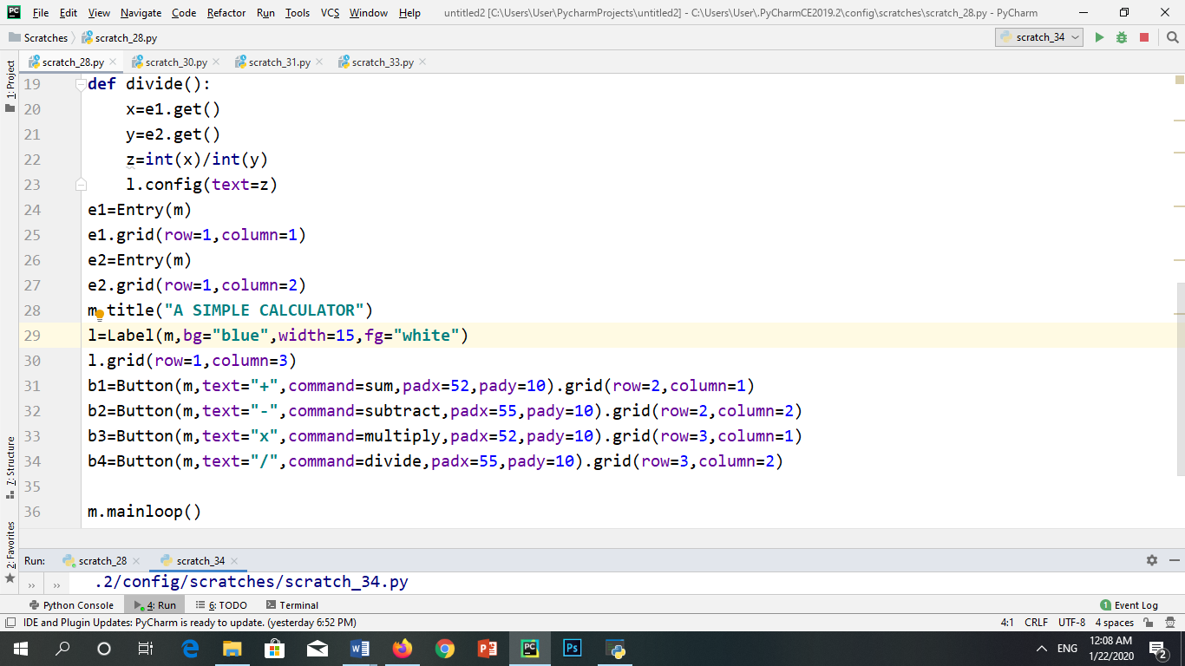

**OUTPUT:**

